CYBERSECURITY RISK ASSESSMENT FRAMEWORK FOR SMALL BUSINESSES

1. Introduction
The project was carried out by following these steps:

1. Research of Cybersecurity Risks
Common cybersecurity risks faced by small and medium enterprises (SMEs) were studied. These included phishing attacks, ransomware, insider threats, weak passwords, and unsecured networks.
2. Development of Risk Assessment Model
A basic risk assessment model was developed based on the NIST Cybersecurity Framework. This helped in structuring the process of identifying and managing risks.
3. Risk Evaluation Metric
A simple method was created to evaluate and rank risks based on their likelihood and impact. This made it easier to identify which threats are more serious.
4. Risk Mitigation Strategies
Different solutions were proposed to reduce cybersecurity risks. These included using firewalls, enabling multi-factor authentication, installing antivirus software, and providing employee training.
5. Validation through Case Study
The model was applied to a small business case study to understand how it works in a real-world situation and to analyze the results.
6. Documentation and Best Practices
All findings were documented, and general best practices were provided to help SMEs improve their cybersecurity and reduce future risks.

2. Common Cybersecurity Risks in SMEs
Some common risks include:
- Phishing attacks
- Ransomware
- Weak passwords
- Insider threats
- Unsecured Wi-Fi networks

3. Risk Assessment Model (NIST-Based)
The project uses a simple model based on the NIST Cybersecurity Framework:
- Identify – Find possible risks
- Protect – Apply security measures
- Detect – Identify attacks early
- Respond – Take action during attack
- Recover – Restore systems

4. Risk Evaluation Table
Threat |  |  | Likelihood (1–5) | Impact (1–5) | Risk Score
Phishing |  |  | 5 | 3 | 15
Ransomware |  |  | 3 | 5 | 15
Weak Passwords |  |  | 4 | 4 | 16
Insider Threat |  |  | 2 | 4 | 8
Unsecured Wi-Fi |  |  | 3 | 3 | 9
Risk Score = Likelihood × Impact

5. Risk Mitigation Strategies
To reduce cybersecurity risks, the following measures are suggested:
- Use strong passwords
- Enable Two-Factor Authentication (2FA)
- Install antivirus and firewall
- Keep systems updated
- Train employees about phishing
- Use secure networks

6. Case Study: Small Retail Shop
A small retail shop uses a computer for billing and storing customer data but does not have proper cybersecurity measures. Employees are also not trained to identify cyber threats.
Risks Identified:
- Weak passwords
- Phishing emails
- No antivirus or firewall
Risk Evaluation:
Using the risk score (Likelihood × Impact), weak passwords had the highest risk, followed by phishing attacks.
Mitigation Strategies:
- Use strong passwords
- Enable Two-Factor Authentication (2FA)
- Install antivirus and firewall
- Train employees
Conclusion:
This case study shows that small businesses can improve their cybersecurity by using simple and basic security practices.

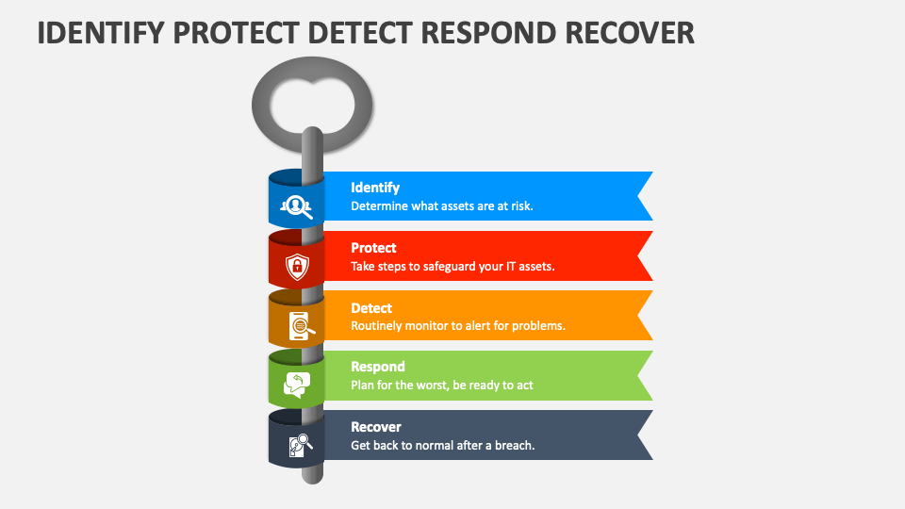
7. Framework Diagram

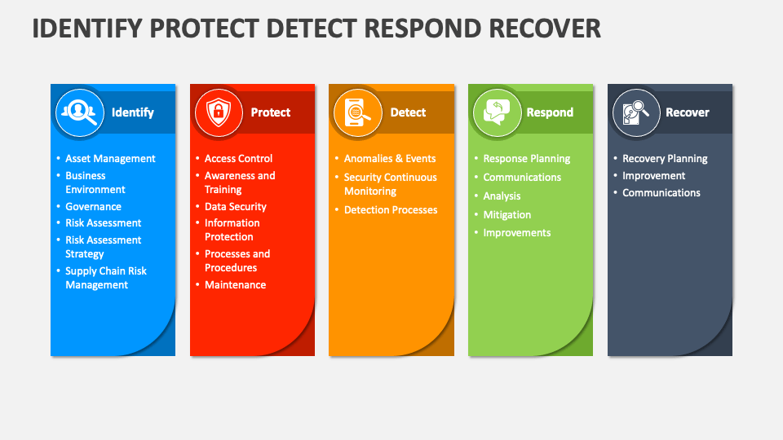
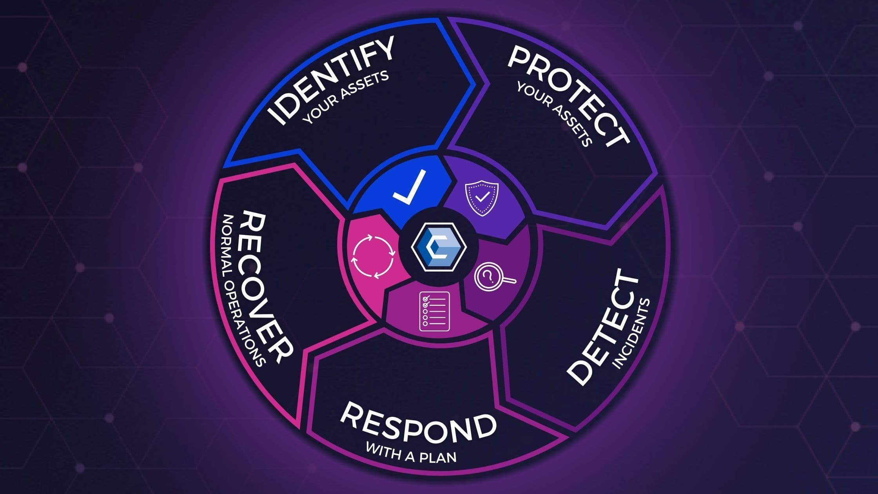
Cybersecurity Risk Assessment Framework (Based on NIST Model)

8. Documentation of Findings
The project shows that small and medium enterprises (SMEs) are highly vulnerable to cyber attacks due to weak security measures and lack of awareness. Common issues include weak passwords, phishing attacks, and absence of proper security tools. Many users do not verify links or follow safe practices, which increases the risk.

Best Practices for SMEs
- Use strong and unique passwords
- Enable Two-Factor Authentication (2FA)
- Install antivirus and firewall protection
- Keep systems and software updated
- Regularly backup important data
- Train employees to identify cyber threats
- Avoid clicking on unknown links

